The partners from Martinique, Poland, Slovakia and Italy arrived over 9th and 10th March 2019, with the Martinique colleagues having the most arduous journey, travelling for approximately 24 hours. Unfortunately, our Turkish partners, were unable to travel.

Monday

Following the welcome to North West Regional College (NWRC) in Londonderry (Derry) project representative Martin Peoples gave an overview of the College and the city and region. Part of the ”getting to know you” exercise involved the students getting into pairs with a student from a different country, finding out some information about that student and providing this information to the whole group. This was a good way to break the ice and let everybody find out some details about each other. The end of the introduction to Derry and NWRC included an online quiz about the city/region, delivered using Kahoot, with all teams demonstrating that they did indeed remember some facts about the place where they were about to spend the next week.

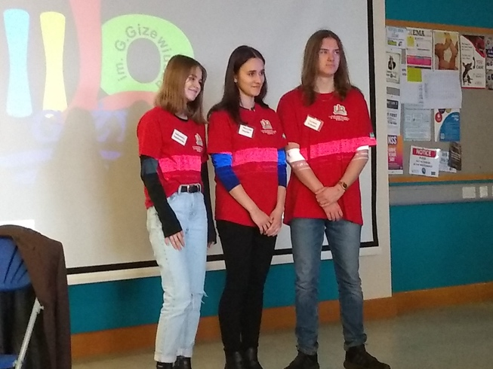
The morning continued with the students doing the completed presentations developed using the Google Arts and Culture app. Each of the teams from Italy, Poland, Slovakia and Martinique made presentations that were well-received by all those present.

On Monday afternoon, the group received a presentation from Dr Fergal Tuffy, Manager of the College’s Business Support Centre (BSC). Fergal described the work that the BSC does in supporting local companies, in particular:
- Research and development of new products and markets
- Staff training
- Advice on use of new technologies.
Fergal was able to tell the group that in the region the most dominant software for general users was Microsoft Office and that Google Apps were generally not used.

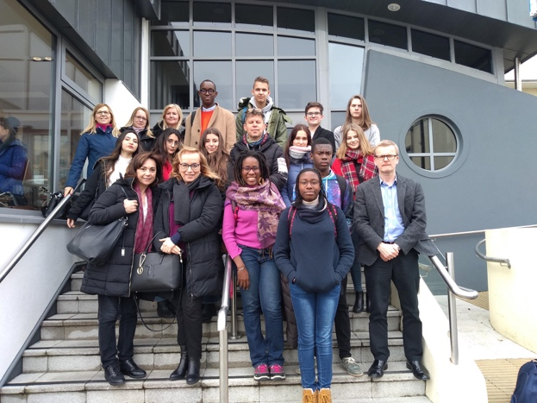
Following the BSC presentation, the group visit the City Mayor, Mr John Boyle, in the City Hall (better known as the Guildhall). The Mayor had a fulsome welcome for the group and provided many opportunities for photographs.

In the evening, visiting pupils and staff were able to attend the NWRC annual Hairdressing and Beauty Show, in the City Hotel. This show is a high profile annual extravaganza of innovative hairdressing and beauty activities, where the College’s students work with students from the Performing Arts courses to put on a show for the people of the city and region, showcasing avant garde hairdressing and makeup displays, accompanied by music and performance, provided by students.

Day one was a long day, with a lot of learning and activities packed in.

Tuesday
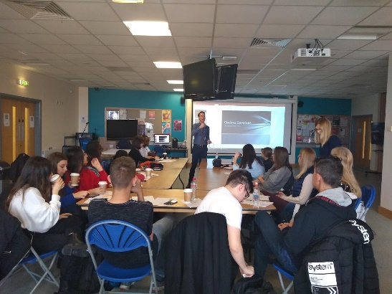
NWRC teacher Thomas Moore (Computing) brought along a group of his Level 3 Computing students to work in partnership with the GOAL students. Each NWRC student partnered one of the visiting students, working through exercise the used QR Code Reader, via iPads, to answer questions, created by Classtools.et and QR Treasure Hunt Generator. The questions were on the subject of Information Technology security. This sample lesson was an excellent way for the pupils to test their knowledge of cyber security and learn new details of that subject. It also presented an opportunity to use the iPads and QR Code apps and for the students to work together.

In the afternoon Liz January and Amanda Cavanagh, Hairdressing Lecturers, brought the group to the practice salon, where Liz demonstrated the technology she uses and the NWRC students gave the GOAL visitors hairdressing services.

The NWRC students collected the customer information using Microsoft Forms app, from their phones, allowing them to have a record of the client/visitor name and hairdressing request.

Liz’s demonstration was an excellent overview of her “paperless class”, where learning materials (notes etc.) were exchanged with students from iPad to smartphone and student’s assessment materials were exchanged back to Liz using the same technology (AirDrop).

Wednesday

Caroline Mc Keever, Lecturer in Health and Care, delivered a Science lesson having 2 learning outcomes, that the participants could:

- Name and label the key organs found in the Digestive System (Anatomy)
- Outline what happens during Digestion (Physiology)
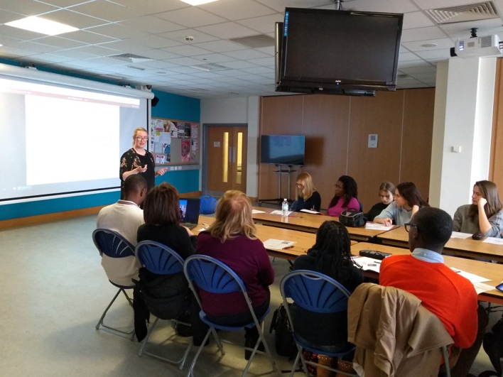
Caroline’s lesson was really interesting, looking at how digestion works, featuring YouTube videos. In addition, Caroline used the Edpuzzle app to take the original YouTube video and add some questions to it at key points in the video. The questions were an opportunity to see what the student viewers understood from the video.

In the afternoon, there were 2 sessions. Martin Peoples delivered some training on how to use YouTube. This session looked at how to maximise the ability for a user’s YouTube videos to be “found”, from the perspective of a teacher and a user in general. This looked at channels and playlists. The workshop continued with looking at some other elements of using YouTube, privacy settings and live streaming.

A practical element of the workshop was to get each of the participants to develop a short video from their region, then upload this to YouTube.

Later in the afternoon, Siobhan Faulkner form NWRC gave the group an overview of the work her team does in supporting students who have disabilities or learning difficulties. In particular, Siobhan gave demonstrations of some of the simple tools that can be used by people who have some form of disability. An example of a tool was the Google audio function, which can be used to spell out a word the user speaks.

On the Wednesday evening, the pupils had the opportunity to join with some others from NWRC and a group of visiting students from Denmark and Germany doing 10-pin bowling. Most of the GOAL pupils took up the opportunity and had a very pleasant evening.
Thursday
Giant’s Causeway
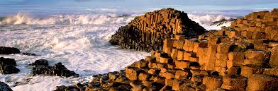
On Thursday, the group had the opportunity to take a visit to Northern Ireland’s most famous tourist attractions, the Giant’s Causeway, which is a World Heritage Site. The Causeway, scientists believe, was created by volcanic activity, 60 million years ago. It is a massive network of 40,000 connected stone columns and is located on Northern Ireland’s north coast, giving a fantastic backdrop of the north Atlantic and on a very bright day a view of Scotland.

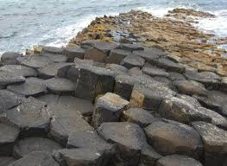
As well as the scientific version of how the Causeway was formed, there is also a legend about it. According to Wikipedia, this is that the columns are the remains of a causeway built by a giant. The story goes that the Irish giant Finn MacCool was challenged to a fight by the Scottish giant Benandonner. Fionn accepted the challenge and built the causeway across the North Channel so that the two giants could meet. In one version of the story, Fionn defeats Benandonner. In another, Fionn hides from Benandonner when he realises that his enemy is much bigger than he is. Fionn's wife, Oonagh, disguises Fionn as a baby and tucks him in a cradle. When Benandonner sees the size of the 'baby', he reckons that its father, Fionn, must be a giant among giants. He flees back to Scotland in fright, destroying the causeway behind him so that Fionn would be unable to chase him down.
The weather on the day itself was windy and wet, with strong winds along with rain coming as the group were beginning to enjoy exploring the actual stones. This however did not stop everybody from enjoying the visit, and taking lots of photographs, some included here.
Ballintoy Harbour
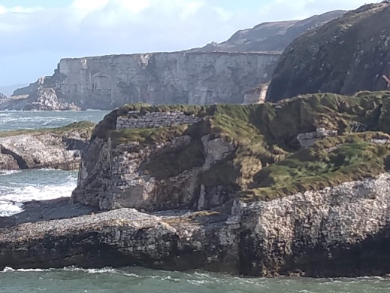
On the way back from the Giant’s Causeway, the group stopped off at Ballintoy Harbour and spent some time there, walking around the harbour and climbing the rocks there. Ballintoy is a very small and pretty place that has gained some fame from being used as the fictional town of Lordsport in the Isle of Pyke second season the television medieval fantasy series, Game of Thrones, which filmed at the harbour in 2011. For this reason, many international visitors, especially from USA, include this place in their tour of N Ireland.
Dinner at the Flying Clipper Restaurant
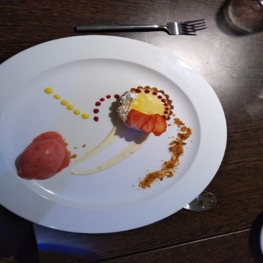
Thursday night provided a much-needed relaxation from an exhausting day. The group had dinner in NWRC’s Flying Clipper Restaurant, where an in-house team of teachers and students prepares the food, with the service also provided by students. All as being excellent regarded the three-course meal, but the opportunity to relax after a long week was equally welcomed.

Friday
On Friday morning, the visiting students created multimedia stories about their visit to Northern Ireland. They used an app called Adobe Spark, and included text, images and audio, to give a summary of their week. Each country created their own version of the week’s story and presented it to the group, see below presentation form one of the Slovakian students.
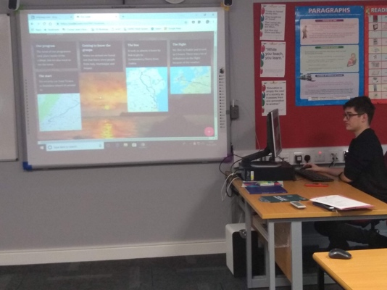
Whilst the pupils were doing their work the teachers had a short workshop looking at the use of mobile devices in learning and teaching, with particular reference to an Erasmus + project, Tablio. This project studied and provided guidance resources on use of mobile devices, especially to use in differentiation and inclusion.
Also on Friday morning and continuing in the afternoon, the teachers spent some time reviewing the project and planning for future mobilities.
This was a busy week for the whole group, with lots of workshops and a variety of apps displayed and used. Most of the group left for home on Saturday, tired but satisfied with their experiences of Northern Ireland. The staff of NWRC was delighted to have hosted them and looked forward to meeting them again in future mobilities.

