The Lycée Polyvalent Nord Atlantique (LPO Nord atlantique) is a high school in Sainte-Marie with 455 students ranging from ages 15-20, around 40 teachers. Located in a rural region of northern Martinique, Sainte- Marie is a town with roughly 18,000 inhabitants. The city is bordered by the Atlantic ocean, which explains the beautiful view on the ocean from a majority of the classrooms. Sugar cane agriculture is a major industry in the town which homes one of the most famous rum distillery of the island “Saint James”.
As a French oversea department, French is the official language along with Creole, the local language. The students of the school, coming from Sainte-Marie and the neighboring cities, have the opportunity to study several foreign languages such as English, Spanish, and Portuguese. Creole is also thought. It is more common to speak Creole than to write it, so the students can officially learn how to properly write Creole at school. Students generally go to school 5 days a week (from Monday to Friday). The lessons starts at 7.30 am and finish at 5pm. They can get up to 6 different subjects a day. Each period is 55mn. Wednesday are half days (7.30-12.30). The subjects cover French, foreign languages, PE, Science, Maths, History and Geography.
Opening the high school to external locations in Europe and other countries globally is a major objective for the educational community. School trips are regularly organized in the school. The students can discover the Caribbean, Canada, and various European countries.
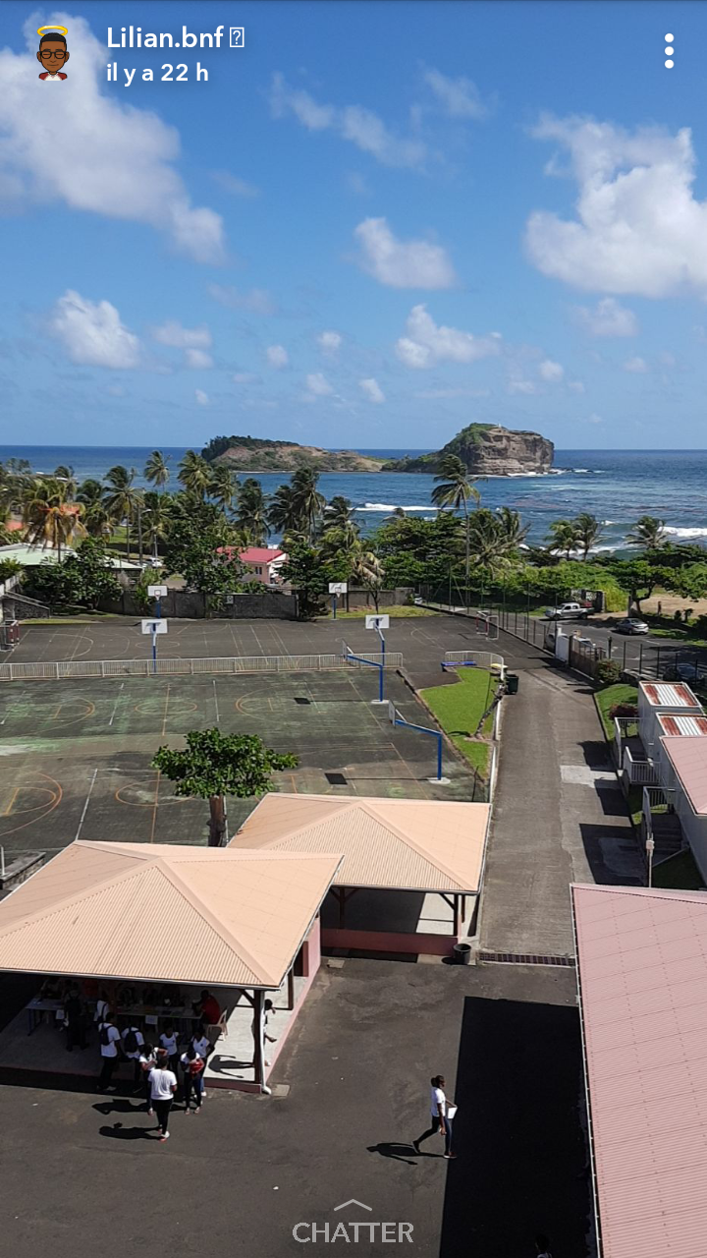 our school
