Webinar on Google Agenda and Google Classroom
December 11th, 2020
Organised by Lycée Nord Atlantique, Martinique
Presented by Miss Lina VON PACZENSKY and Sabrina SINEPHRO
During this workshop, Poland, Turkey and Italy were present and could discover Google Calendar and Google Classroom. As for Martinique all the students (15) implied in the mobility were present accompanied by their 2 teachers.
Miss Lina VON PACZENSKY, is a Google educator specialist who owns a Digital Training Center & Incubator in Fort-de-France in Martinique. She has a great experience in Google Applications as she has had the opportunity to work for Google in Ireland. After starting with a short introduction of herself, of the partners and our project GOAL, we attended a workshop of 2 hours. It unfolded into 2 parts:
Part 1: Discovering and practise Google Calendar
○ Sharing and smart scheduling
○ Tasks & Keep
○ Set up Google Calendar
○ Build a presentation to present Calendar to the other partners.
Part 2: Discovering and practising Google Classroom
○ Tasks & Keep
○ How teachers and students can use Google Classroom in class
Between the 2 parts we had the chance to have a private talk with Miss Lina VON PACZENSKY. She came back on her experience as a Google Educator and other aspects of her professional expertise.
Two hours later, the Workshop ended in a good ambiance, all partners satisfied with this virtual experience. We concluded that we would call Miss Lina VON PACZENSKY to help up us in our future workshops.

Part 1 : Google Calendar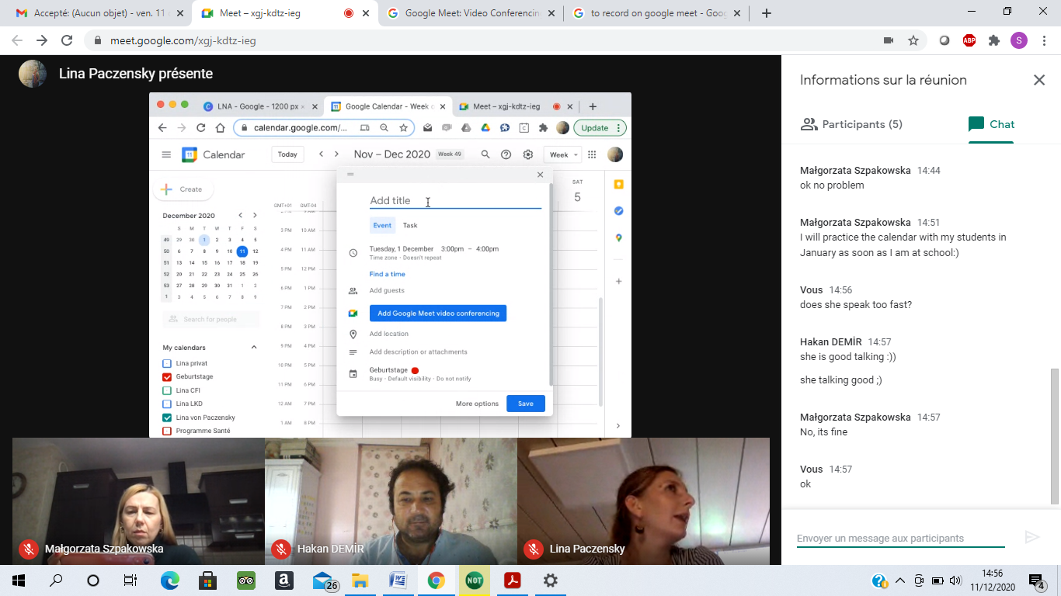
Chit-chat during break time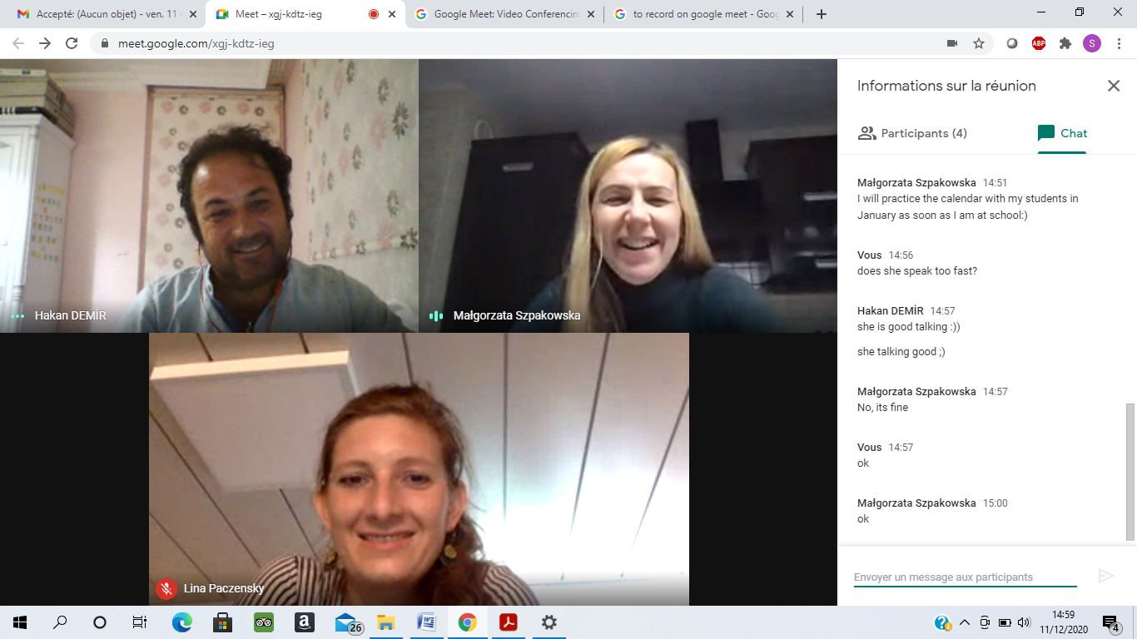

Part 2: Google Classroom

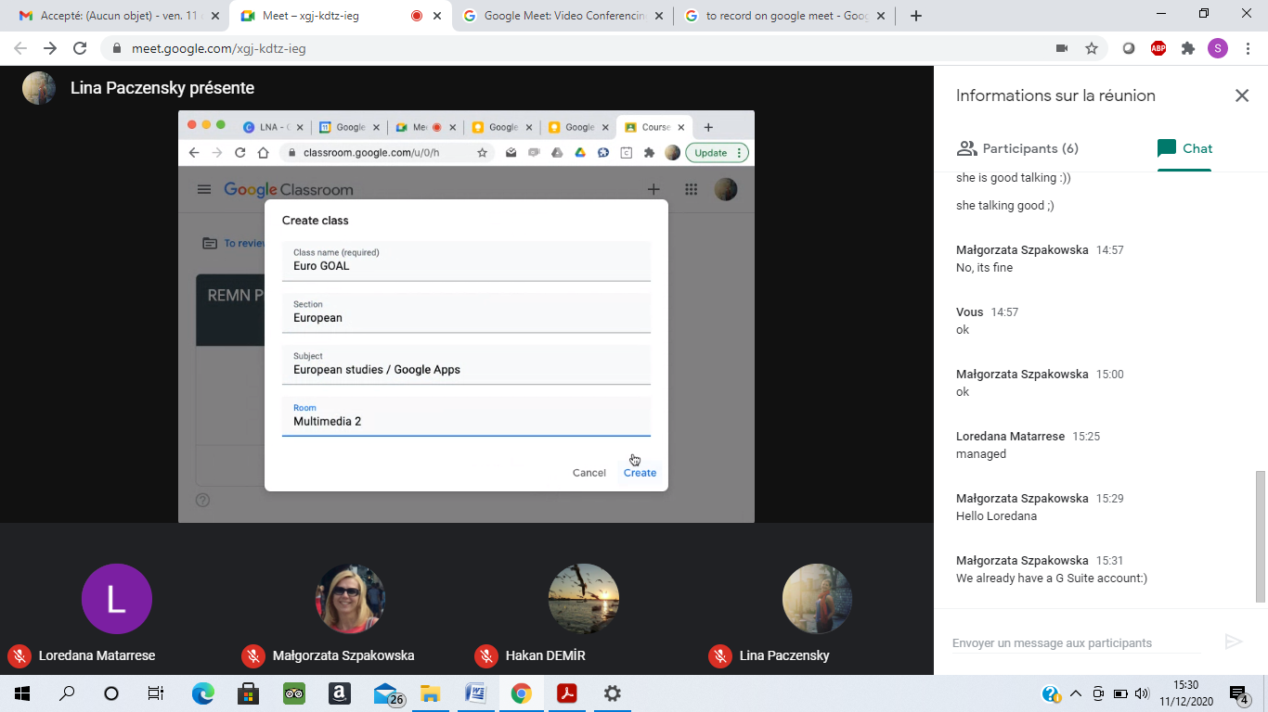

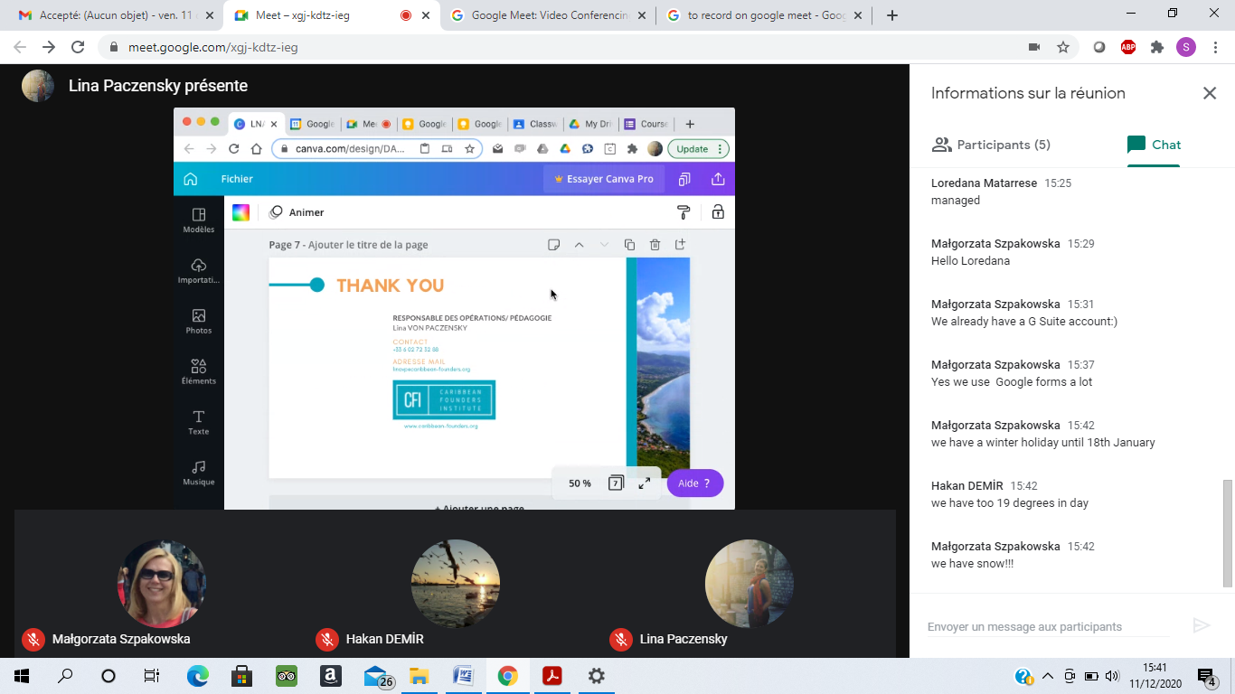

Thank you and Goodbye!

